REAL-WORLD DATASET ANALYSIS PROJECT
Global Superstore Sales Data Analysis
Internship Task – Data Analysis
Python • Pandas • NumPy • Matplotlib • Seaborn • Jupyter Notebook
Dataset Source: Kaggle – Global Superstore

Student Name: Yash Vikram Jadhav
Program: B.Sc. Artificial Intelligence
Institute: Yashwantrao Chavan Institute of Science (YCIS), Satara
Task: REAL-WORLD DATASET ANALYSIS PROJECT

Environment: Python + Jupyter Notebook

1. Executive Summary
This report presents an end-to-end analysis of the Global Superstore dataset. The cleaned Orders data contains 51,290 records and 28 columns. The project examines data quality, sales, profitability, products, regions, customer segments, discounts, time trends, correlations, and potential outliers.
Total sales are 12,642,501.91, total profit is 1,467,457.29, and total quantity is 178,312. The overall profit margin is 11.61%. The results demonstrate why business performance should be evaluated using both revenue and profitability.

2. Project Objectives
- Understand the structure and business context of the dataset.
- Identify missing values, duplicate records, and data-quality issues.
- Clean and preprocess the data using appropriate techniques.
- Perform exploratory and descriptive analysis using Pandas and NumPy.
- Analyze sales, profit, products, customers, regions, segments, discounts, and time trends.
- Create meaningful visualizations to communicate findings.
- Develop actionable business insights and recommendations.

3. Dataset Description
Global Superstore is a transactional retail dataset containing order, customer, product, geographic, shipping, sales, discount, and profit information.
Metric | Value
Records after duplicate removal | 51,290
Columns | 28
Original duplicate records | 0
Total missing cells | 41296
Columns with missing values | 1
Total Sales | 12,642,501.91
Total Profit | 1,467,457.29
Total Quantity | 178,312
Average Sales | 246.49
Average Profit | 28.61
Profit Margin | 11.61%

4. Methodology
The analysis followed a standard data-science workflow: data loading, structural inspection, data-quality assessment, cleaning, feature engineering, descriptive statistics, exploratory analysis, visualization, relationship analysis, interpretation, and recommendations.
- Loaded the Orders sheet using Pandas.
- Inspected dimensions, columns, data types, and summary statistics.
- Checked and removed duplicate records.
- Checked missing values.
- Converted Order Date and Ship Date to datetime format.
- Created Year, Month, Quarter, and Shipping_Days features.
- Performed category, region, product, segment, and time-based analysis.
- Analyzed discount-profit and numerical correlations.
- Inspected potential outliers without automatically deleting legitimate transactions.

5. Data Cleaning and Preprocessing
The original Orders data contained 0 duplicate record(s), which were removed before analysis. Missing values were quantified across all columns. Date fields were converted to datetime format and new temporal and shipping-duration features were created.
Potential outliers were treated as observations requiring investigation rather than automatically deleting them. In business data, extreme orders may be legitimate.

6. Exploratory Data Analysis

6.1 Sales by Category
Technology generated the highest total sales at 4,744,557.50.
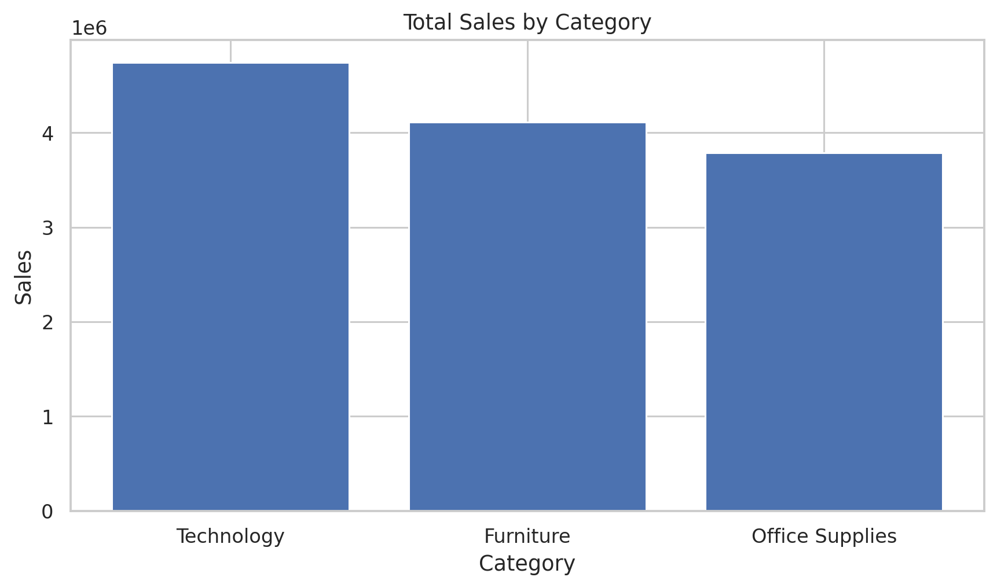

6.2 Regional Performance
Central generated the highest total sales at 2,822,302.52.
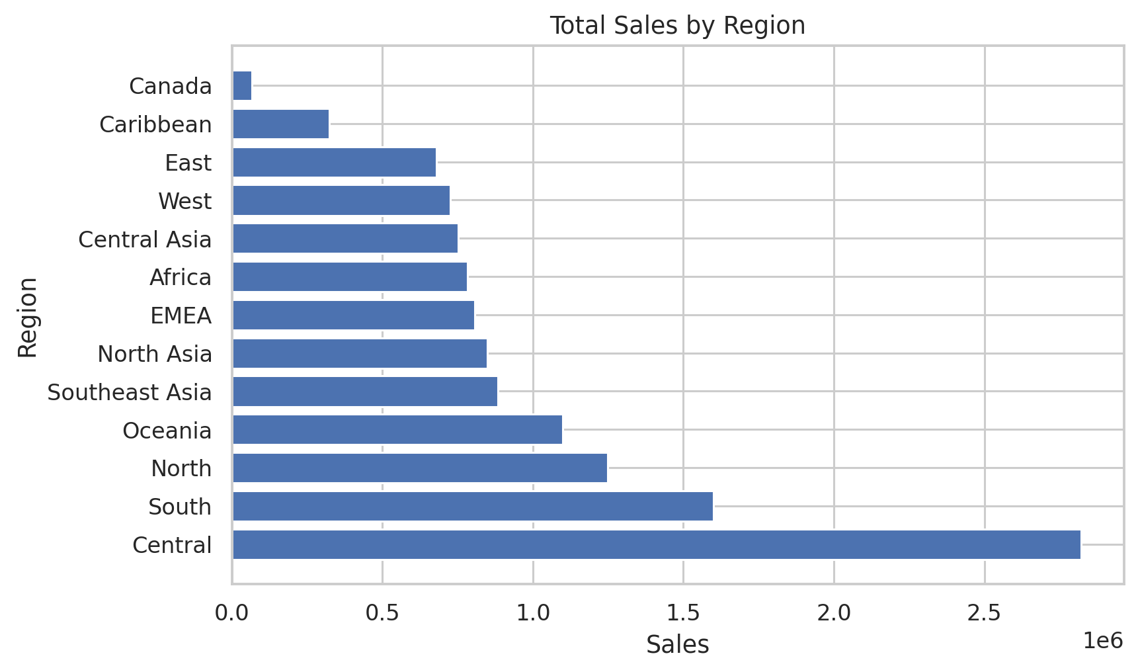

6.3 Monthly Sales Trend
Monthly aggregation was used to identify changes in demand over time and support planning.
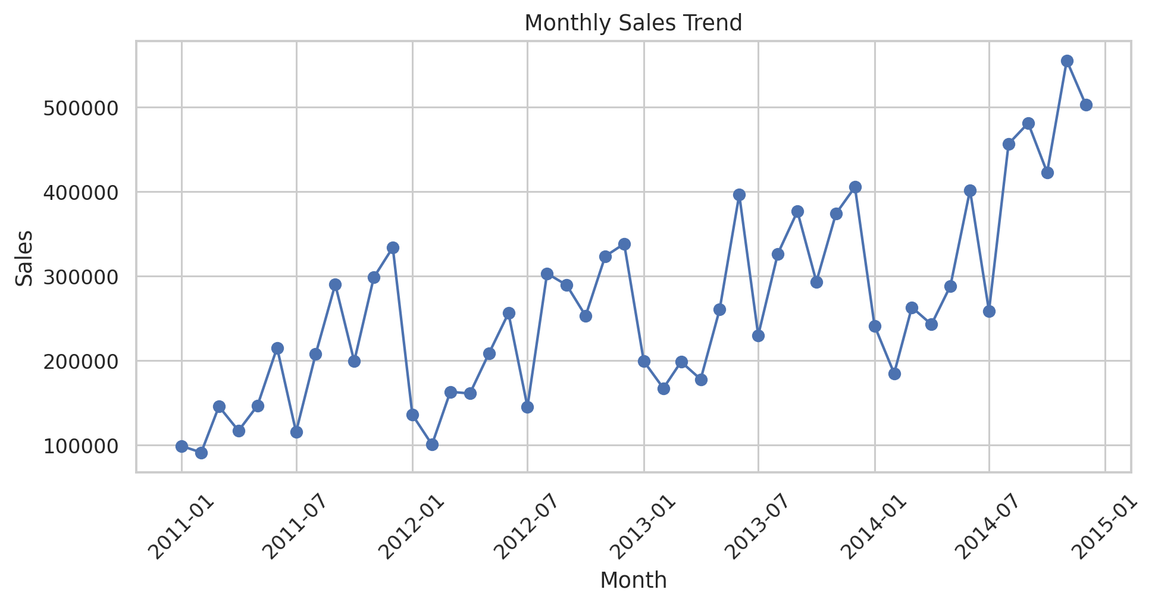

6.4 Product Performance
Rank | Product | Sales
1 | Apple Smart Phone, Full Size | 86,935.78
2 | Cisco Smart Phone, Full Size | 76,441.53
3 | Motorola Smart Phone, Full Size | 73,156.30
4 | Nokia Smart Phone, Full Size | 71,904.56
5 | Canon imageCLASS 2200 Advanced Copier | 61,599.82
The lowest aggregate-profit product is Cubify CubeX 3D Printer Double Head Print, with profit of -8,879.97. Such products should be reviewed for pricing, discounting, costs, and demand.

6.5 Customer Segment Analysis
Segment | Sales | Profit | Quantity | Avg Discount
Consumer | 6,507,949.42 | 749,239.78 | 92,157 | 14.36%
Corporate | 3,824,697.52 | 441,208.33 | 53,565 | 14.29%
Home Office | 2,309,854.97 | 277,009.18 | 32,590 | 14.09%

6.6 Discount and Profitability
The Pearson correlation between Discount and Profit is -0.316. This represents a linear association in the dataset and should not be interpreted as proof of causation.
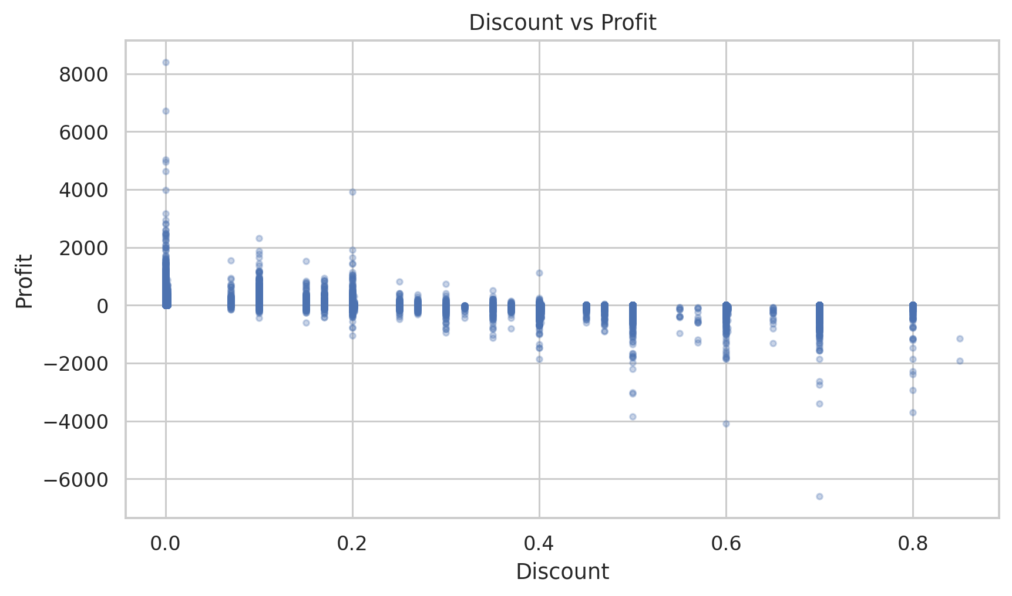

6.7 Correlation Analysis
The correlation matrix compares Sales, Quantity, Discount, and Profit to identify linear relationships.
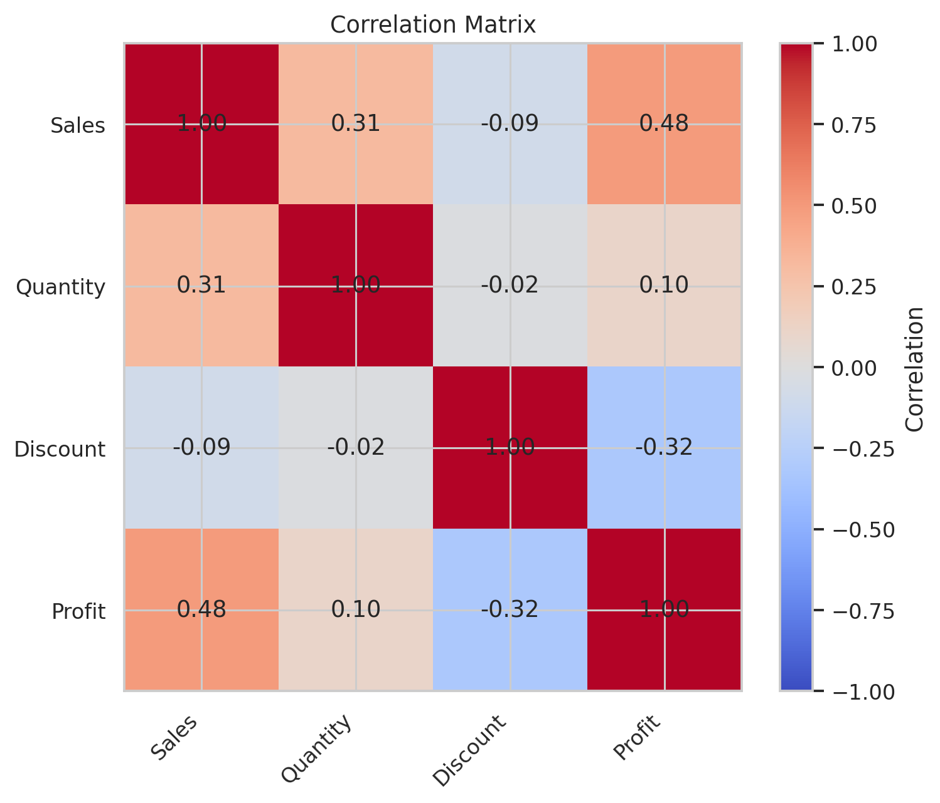

7. Key Findings
- Total sales are 12,642,501.91 and total profit is 1,467,457.29.
- The overall profit margin is 11.61%.
- Technology is the leading category by total sales.
- Central is the leading region by total sales.
- Product analysis identifies both high-selling and loss-making products.
- Monthly sales vary over time and provide useful planning information.
- The Discount–Profit Pearson correlation is -0.316.
- Revenue alone is not sufficient for evaluating business performance.

8. Business Recommendations
- Prioritize high-performing categories and regions while monitoring profitability.
- Review loss-making products for pricing, discount, product-cost, and shipping issues.
- Use discounting strategically and evaluate discounts against profit, not sales alone.
- Use historical monthly patterns to improve inventory and campaign planning.
- Develop customer-segment strategies using both revenue and profitability.
- Monitor regional performance regularly to identify growth opportunities and weaknesses.
- Build dashboards that track Sales, Profit, Profit Margin, Quantity, Discount, and regional performance together.
- Combine transactional data with marketing, cost, and retention data in future analysis.

9. Limitations
- The dataset does not contain every operational factor affecting profitability.
- Correlation indicates association and does not prove causation.
- Potential outliers were inspected rather than automatically removed.
- Recommendations should be validated against current business conditions.

10. Conclusion
This project demonstrates a complete real-world data-analysis workflow using Python and the Global Superstore dataset. It covers data inspection, cleaning, preprocessing, exploratory analysis, visualization, correlation analysis, and business interpretation.
The analysis shows that combining sales, profit, discount, product, regional, customer, and time-based metrics provides a more useful view of business performance than revenue alone.

11. Tools and Technologies
- Python
- Pandas
- NumPy
- Matplotlib
- Seaborn
- Jupyter Notebook
- Microsoft Word
End of Report

